art basel
THE MEGA GUIDE TO ART BASEL MIAMI BEACH 2012: WEDNESDAY
GARY PINI | DECEMBER 5, 2012 10:30 AM
Check in daily for our comprehensive coverage of everything that's happening at Art Basel Miami Beach 2012.
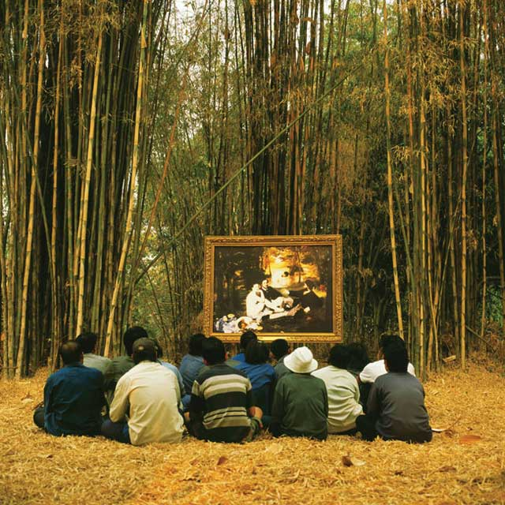
This year's edition of "the world's biggest arty party," Art Basel Miami Beach 2012, officially starts today, December 5, with the opening night VIP vernissage at the Miami Beach Convention Center (1901 Convention Center Drive, Miami). It will be open to the public through Sunday, December 9.
Art and hip-hop collide tonight at the Miami Beach Convention Center. While half of the building hosts the VIP opening of Art Basel, the other half booked a mega rap concert starring Rick Ross, Meek Mill, Wale and Machine Gun Kelly. We're tempted to go to both, but expect total gridlock in South Beach.
The Bass Museum of Art (2100 Collins Avenue, Miami Beach) will be showing six individual solo projects during AB/MB in a special exhibit called "The Endless Renaissance." Rather than mount a curated group show, they'll be featuring six contemporary artists:Eija-Liisa Ahtila (Finland), Barry X Ball (USA), Walead Beshty (UK), Hans-Peter Feldmann (Germany), Ged Quinn (UK) and Araya Rasdjarmrearnsook (Thailand; photo above). The big opening is tonight from 9 p.m. to midnight and the museum is open to the public all week.
Works by 22 artists have been selected to be part of Art Public -- an outdoor exhibit in Collins Park (Collins Avenue between 21st and 22nd Streets, Miami Beach) produced as a collab with the Bass Museum. The works include large-scale sculpture, video, installations and live performances. It all starts with a big opening night party tonight that's open to the public from 8 to 10 p.m. with performances by Jason & Alicia Hall Moran, the Broke People's Baroque Theater and Alex Israel. Also look for an "art-bar" installation called Guiro that's open daily from 5 to midnight and is sponsored by Absolut. The wooden, oval-shaped bar was created by the artist collective Los Carpinteros. There's also a "soccer pitch on the moon" called Luna Park by the art duoKOLKOZ with matches at 4 p.m. on the 6th, 7th and 8th. We wonder who's playing?
Vault Magazine and Fabian Basabe present the first Miami exhibit by Marcello Jori at Ocean House in South Beach with an early-evening cocktail party.
The annual "invite only" Jeffrey Deitch/MoCA LA party stars Lykke Li, plus DJ sets from Miike Snow's Andrew and Pontus, and Bjorn from Peter Bjorn and John. As usual, it's all happening at the Raleigh (1775 Collins Avenue, Miami Beach). Lykke goes on at 11 p.m. Sponsors include Vanity Fair, STARZ, Samsung Galaxy and Russian Standard Vodka.
Nur Khan opens a pop-up version of his Electric Room at the Dream South Beach (1111 Collins Avenue, Miami Beach) with Julian Lennon and NYC's Morrison Hotel Gallery and DJs Alison Mosshart of The Kills and Bob Gruen. Tomorrow there's an "evening with The Whitney." Go late.
Valentino, Interview and Sofia Sanchez Barrenchea host a cocktail party at The Webster (1220 Collins Avenue, Miami Beach) with DJChelsea Leyland. Why? Polka dots, of course. While you're shopping at The Webster, be sure to pick up a copy of "Miami: The Fashion & Friendly Guide" by the stores co-founder Laure Heriard Dubreuil. It's filled with tips on what to see and do in Miami.
The Vizcaya Museum and Gardens (3251 South Miami Avenue, Miami), with Andrea Rosen Gallery and White Cube, host a screening of Josiah McElheny's "The Light Club of Vizcaya: A Women's Picture" at 9 p.m. RSVP to cap@vizcayamuseum.org.
Christie's will host their third annual exhibition during Basel/Miami with highlights from an upcoming London auction, "The Art of the Surreal." It will be up from today through Friday, 10 a.m. - 5 p.m., at the JW Marriott Marquis (345 Avenue of the Americas, Miami). It's free and open to the public.
Ballroom Marfa -- the Texas non-profit arts and culture organization -- hosts an "invite only" VIP beach party in the cabanas at the new SLS Hotel South Beach (1701 Collins Avenue, Miami Beach) tonight.
Benrimon Contemporary and Matsuda Eyewear host "Opening: A Video Installation" in honor of Ben Weiner at Haven (1237 Lincoln Road, Miami Beach) at 9 p.m.
You're probably noticed airplanes pulling advertising banners over your favorite beach during the summer. Now imagine what those banners would look like if you gave 15 artists free rein to design the message or the image. The Morgans Hotel Group is doing just that in a cool project called "Plane Text" with artists including Ed Ruscha, Richard Prince, John Baldessari, Jack Pierson,Gary Simmons and Jenny Holzer. The art will be airborne daily starting today. Look up!
Morgans Hotel Group will be opening a pop-up, "members only" version of the Parisian nightclub Silencio in their Delano South Beach (1685 Collins Avenue, South Beach). The original club was designed by David Lynch and is named after the club in his filmMulholland Drive.
Steinway & Sons' "Pop-Up Piano" is back this year with a big fundraiser at the Perry Hotel (2377 Collins Avenue, Miami Beach), 8:30 to 11:30 p.m. The party benefits Miami's New World Symphony and includes performances by Elew, Yuna and DJ YSL and there's also a silent auction. Tickets are available here.
Dior Homme and W host the world premier of a new film by Bruce Weber called "Can I Make the Music Fly?" This is a VIP/invite-only affair that includes a special performance by Toronto band Azari & III following the screening.
Del Toro celebrates their new boutique with an installation by local and international artists tonight from 5 to 11 p.m. in the Wynwood Building (2750 NW 3rd Avenue, Miami).
Controversial LA street artist Alec Monopoly is hosting a "Do Not Pass Go" exhibit/party tonight in a new South Beach spot called the Rec Room (1690 Collins Avenue, Miami Beach). Music provided by the Chainsmokers -- lucky for them, you can still smoke in Miami clubs -- plus Ryan Skolnick and Equal. It's hosted by Curate LA and Black Banditz. Go after midnight or go to jail.
ArtSpot Miami is a new fair-within-a-fair that will pop up in the Red Dot Art Fair tent in Midtown Miami today through Sunday. Organized by Chicago gallerist Aldo Castillo, it will include 12 galleries in a unique environment. "Given the current world market fluctuations and ever expanding nature of the art fair business model, my mission is to maximize art fair exposure and productivity to forward thinking galleries and artists in top global markets such as China and the U.S.," says Castillo.
Photo Credit: Araya Rasdjarmrearnsook, Two Planets: Manet's Luncheon on the Grass and the Thai Villagers, 2012
THIS STORY WAS PUBLISHED ON DECEMBER 5, 2012 10:30 AM

