Art World

Here Are 51 New York Gallery Shows That You Need to (Somehow) See This September
There's no shortage of great art in New York this fall.
Sarah Cascone, September 7, 2017
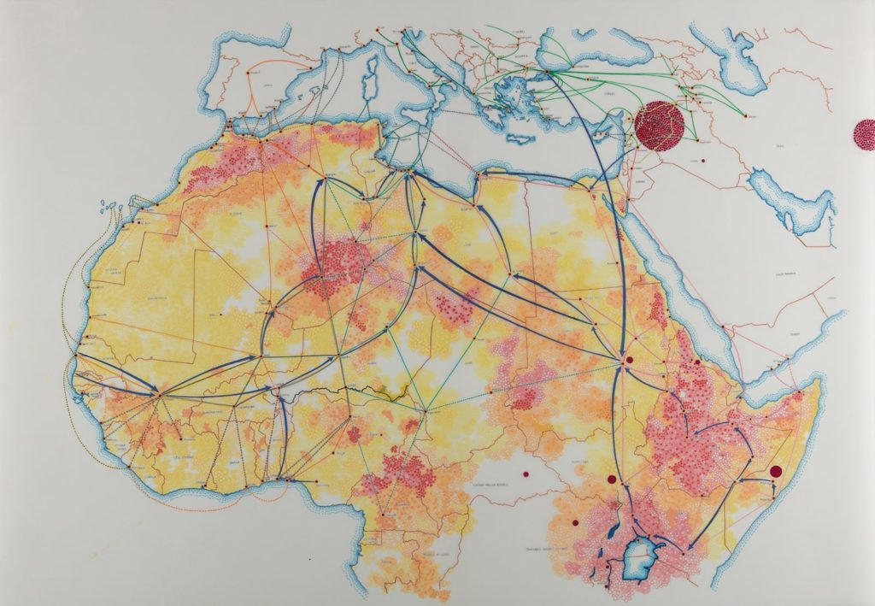
Tiffany Chung, ICMPD, IOM, Frontex, Reuters, NYT: migration routes through Africa to Europe (2017). Courtesy of Tyler Rollins Fine Art.
9. “Tiffany Chung: The Unwanted Population” at Tyler Rollins Fine Art
The current refugee crisis has inspired Tiffany Chung to create cartographic work that documents the displacement of people around the globe. Based on extensive academic research and ethnographic fieldwork, Chung’s drawings serve as historical records as well as visual objects.
529 West 20th Street, 10W, September 7–October 21, 2017; opening reception 6 p.m.–8 p.m.

